**UNIVERSITY INSTITUTE OF COMPUTING**

**PROJECT REPORT**

**ON**

**BOOK STORE SYSTEM**

Program Name: BCA

Subject Name/Code: Data Structures(23CAT-201)

**Submitted by: Submitted to:**

**Name:** Moayed,Ashir,Karma,Pema **Name:** Mrs. Anika Garg

**UID:** 23BCA10250

23BCA10669

23BCA10681

23BCA10682

**Section:** BCA – 7 “B”

***Introduction:***

***This code provides a clear and concise implementation of the given algorithm. It uses a structured approach with clear function definitions for each task, making the code easy to understand and maintain. The code also includes input validation to ensure the user's choices are within the valid range.***

Technique:

Algorithm: * Welcome message: Print a welcome message to the user.

* Display categories:

* Call the displayCategories function to display a list of available categories to the user.

* Each category is presented with a corresponding number.

* Get category choice:

* Prompt the user to enter the number of the category they want to select.

* Read the user's input and store it in the categoryChoice variable.

* Validate category choice:

* Check if the entered categoryChoice is within the valid range (1 to the total number of categories).

* If the choice is invalid, print an error message and exit the program (return 1).

* Display authors:

* Based on the valid categoryChoice, access the corresponding category from the categories vector using categories[categoryChoice - 1].

* Call the displayAuthors function to display a list of authors within the selected category.

* Each author is presented with a corresponding number.

* Get author choice:

* Prompt the user to enter the number of the author they want to select.

* Read the user's input and store it in the authorChoice variable.

* Validate author choice:

* Check if the entered authorChoice is within the valid range (1 to the total number of authors in the selected category).

* If the choice is invalid, print an error message and exit the program (return 1).

* Display books:

* Based on the valid categoryChoice and authorChoice, access the corresponding author from the authors vector within the selected category using categories[categoryChoice - 1].authors[authorChoice - 1].

* Call the displayBooks function to display the list of books written by the selected author.

* End: Exit the program (return 0).

Explanation of the Code:

The code defines three custom functions:

* displayCategories: This function takes a vector of Category objects as input anditerates through it, printing the name of each category along with a corresponding number.

* displayAuthors: This function takes a Category object as input and iterates through its authors vector, printing the name of each author within the category along with a corresponding number.

* displayBooks: This function takes an Author object as input and iterates through its books vector, printing the title and summary of each book written by the author.

The main function serves as the program's entry point. It performs the following steps:

* Prints a welcome message.

* Initializes a vector of Category objects containing sample data (categories, authors, and books).

* Declares variables categoryChoice and authorChoice to store user input for category and author selection.

* Calls the displayCategories function to show available categories.

* Prompts the user to enter their category choice and reads the input into categoryChoice.

* Validates the entered categoryChoice.

* Calls the displayAuthors function to show available categories.

* Prompts the user to enter their category choice and reads the input into categoryChoice.

* Validates the entered categoryChoice.

* Calls the displayAuthors function to show authors within the chosen category.

* Prompts the user to enter their author choice and reads the input into authorChoice.

* Validates the entered authorChoice.

* Calls the displayBooks function to show books written by the selected author.

* Exits the program.

System Configuration:

* **OS:** Windows 10 or Linux
* **Processor:** Intel Core i3 (minimum); Core i5 or higher recommended
* **RAM:** 4 GB (minimum); 8 GB recommended
* **Development Environment:** Any C++ IDE (e.g., Visual Studio, Code::Blocks) or Visual Studio Code with a C++ compiler (GCC or Microsoft C++ Compiler)

SUMMARY

Input:

**Main Menu:**

* The user is welcomed to BookDB, :
  + **First: choose the type of book**
  + **Second: choose 3 Authors from your type**
  + **After selecting the author books of choise and their summarize are their.**

Output:

The Process:

Main Menu:

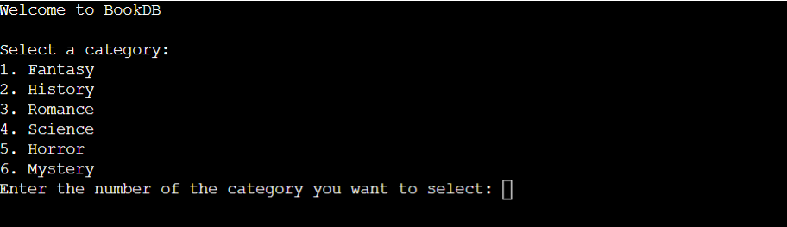

Options and chooses 